**NAAN MUDHALVAN**

SALESFORCE DEVELOPER PROJECT REPORT

PROJECT TITLE: EVENT MANAGEMENT SYSTEM

ST.ANNE’S COLLEGE OF ENGINEERING AND TECHNOLOGY

DONE BY :

# RAGHUL .R REG NO : 422120114311

NM ID : 53094D6EEAAAFEF934746FD882E2777E

* Build An Event Management System Using Salesforce o Salesforce
  + - Creating A Salesforce Developer Org
    - Developer Edition Link

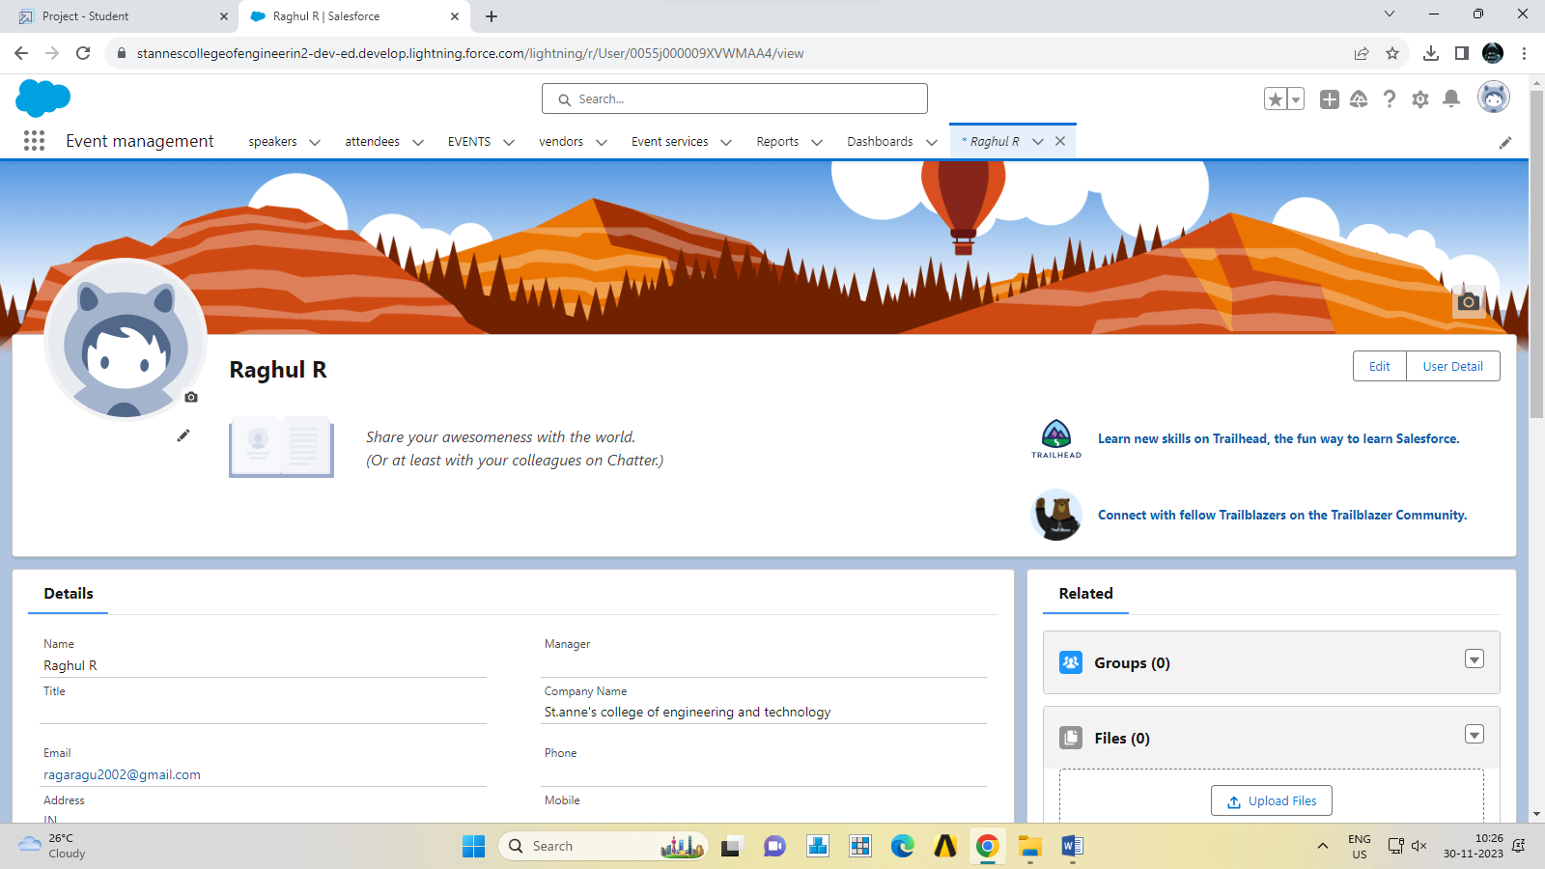

* Object
  + - Creation Of Objects for Event Management

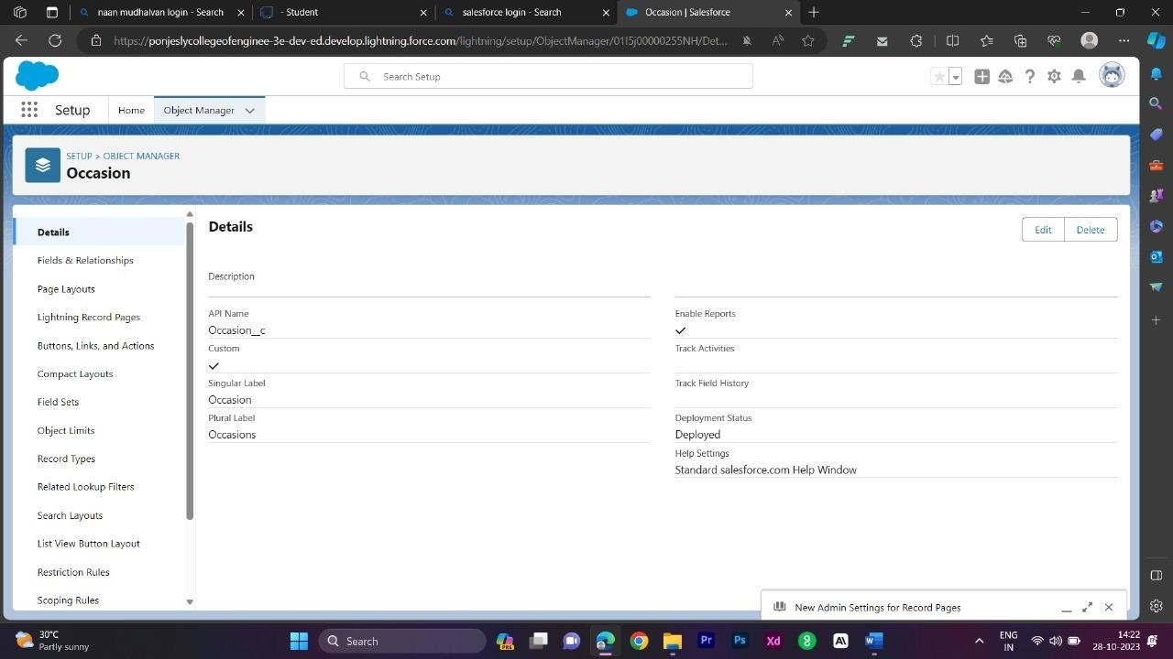

* + - Creation Of Attendees Object

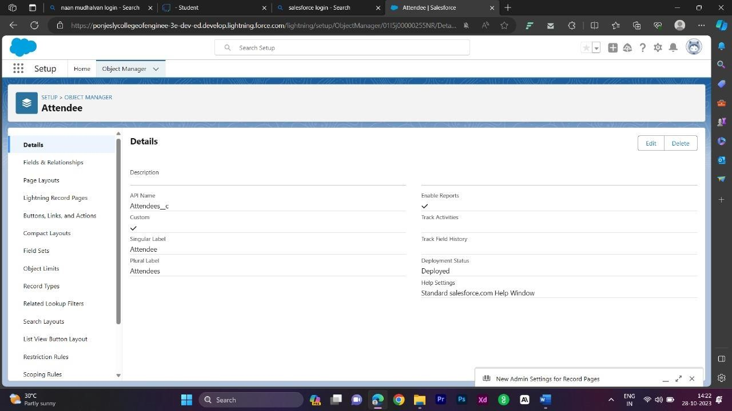

* + - Creation Of Speaker Object

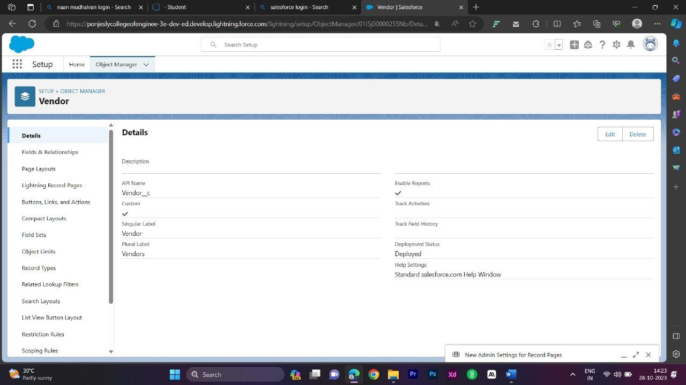

* + - Creation Of Vendors Object

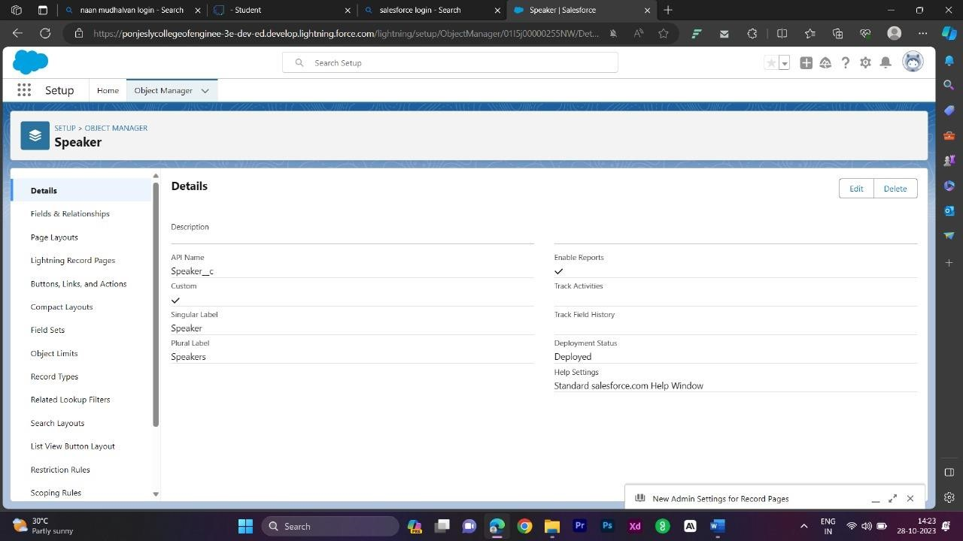

* + - Creation Of Event Service Object

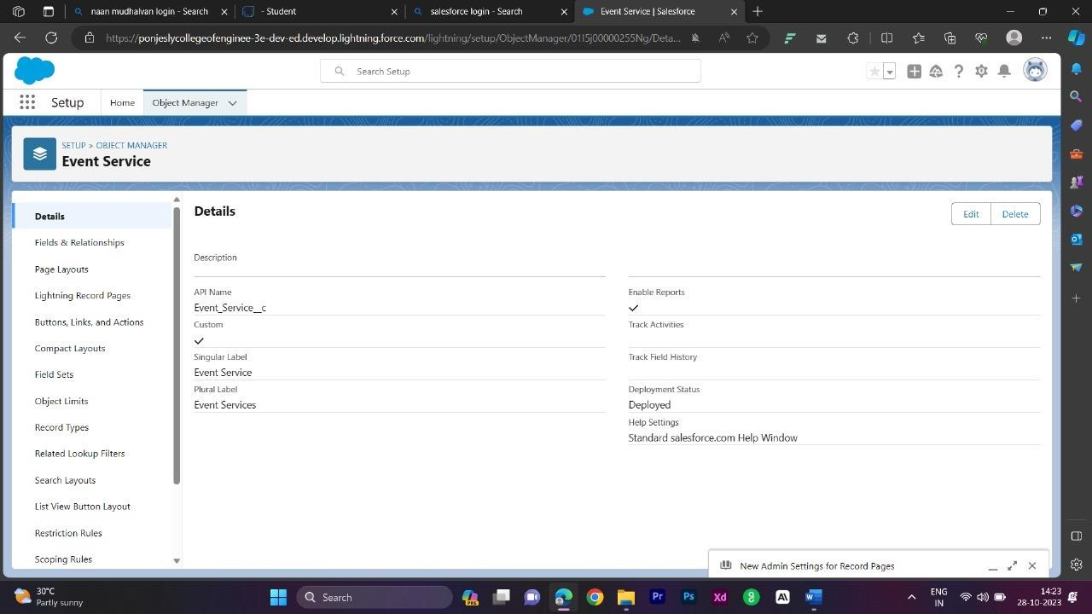

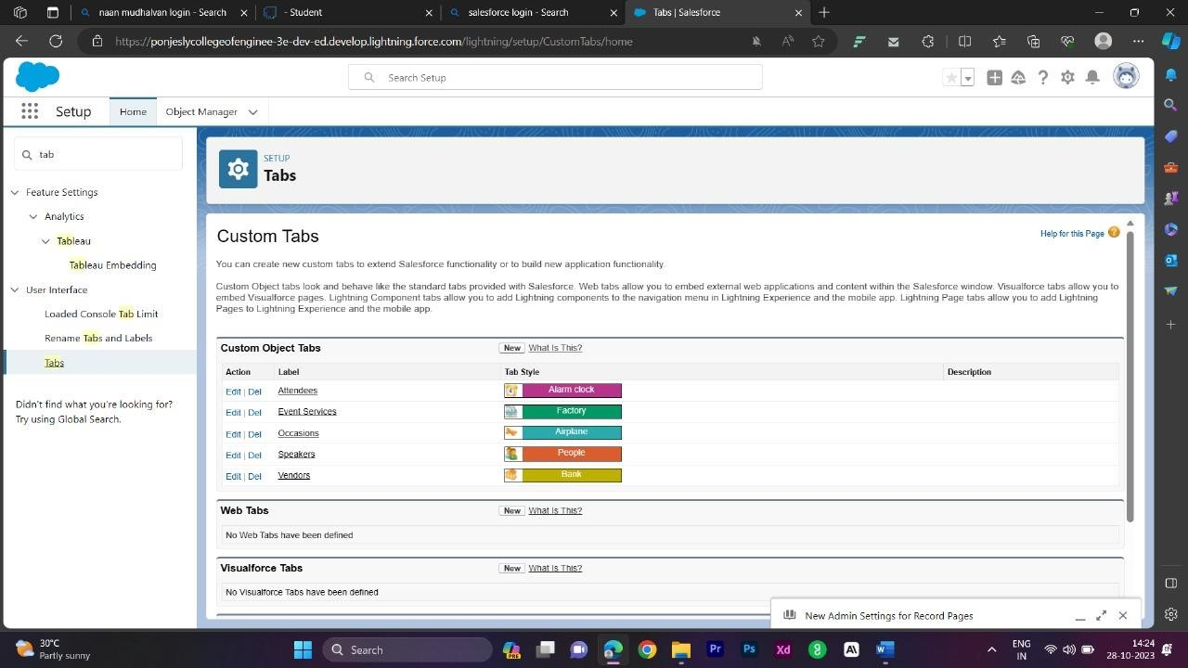

* Tab
  + Creation Of Occasion Tab
  + Creation Of Attendee Tab
  + Creation Of Speakers Tab
  + Creation Of Vendor Tab
  + Creation Of Event Service Tab

* Lightning App
  + Create The Event Management App

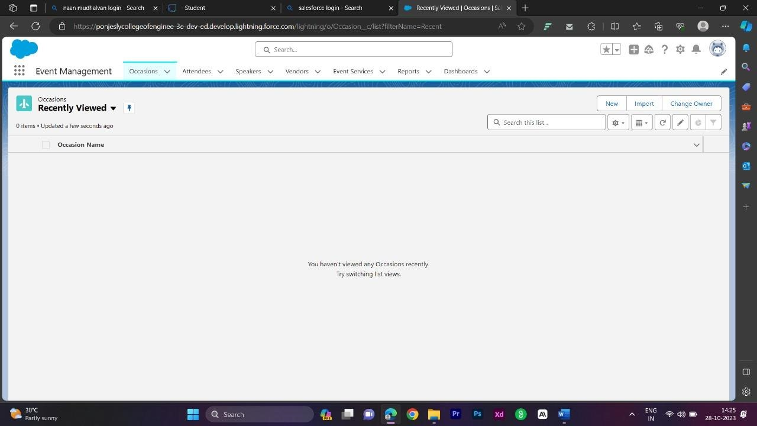

* Fields And Relationships
  + - Creation Of Fields For The Occasion Objects

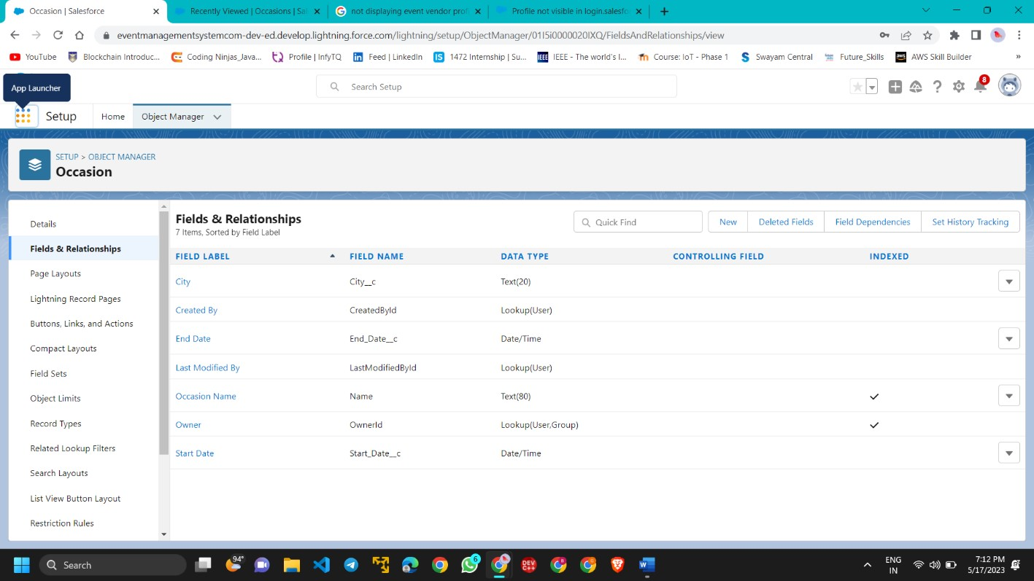

* + - Creation Of Fields For The Attendees Objects

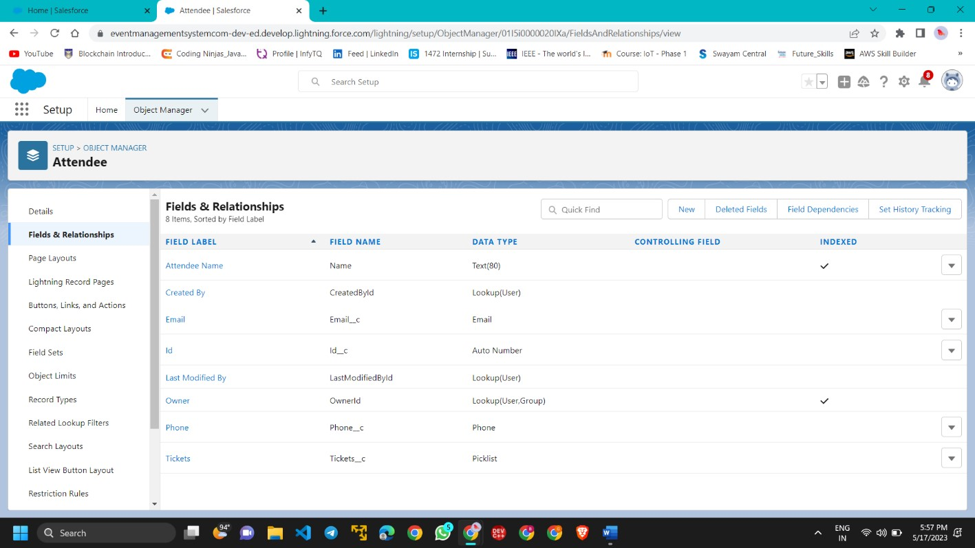

* + - Creation Of Master-Detail Relationship

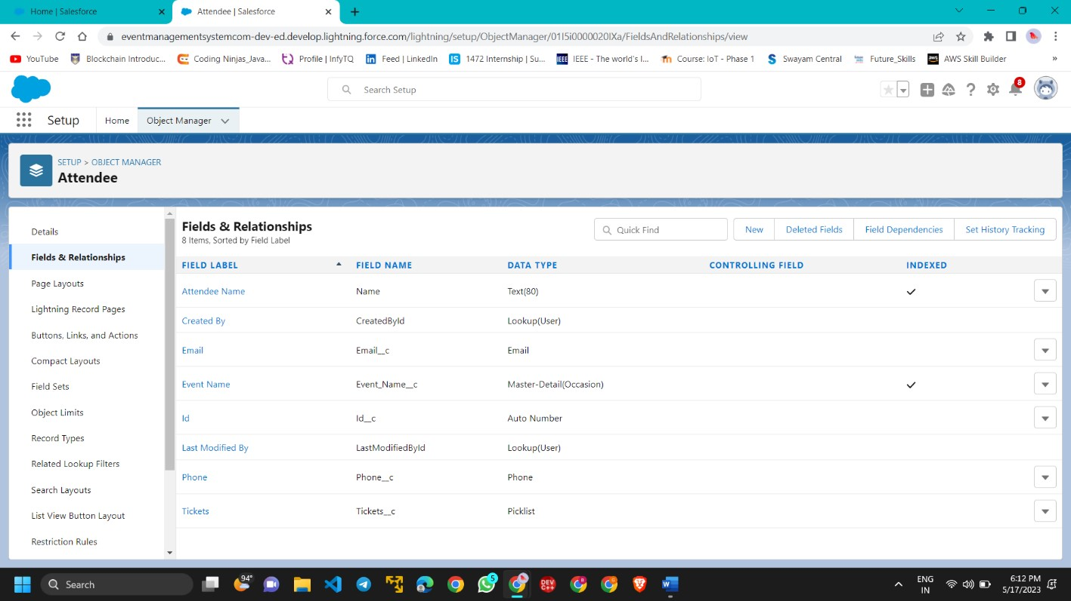

* + - Creation Of Fields For The Speakers Objects

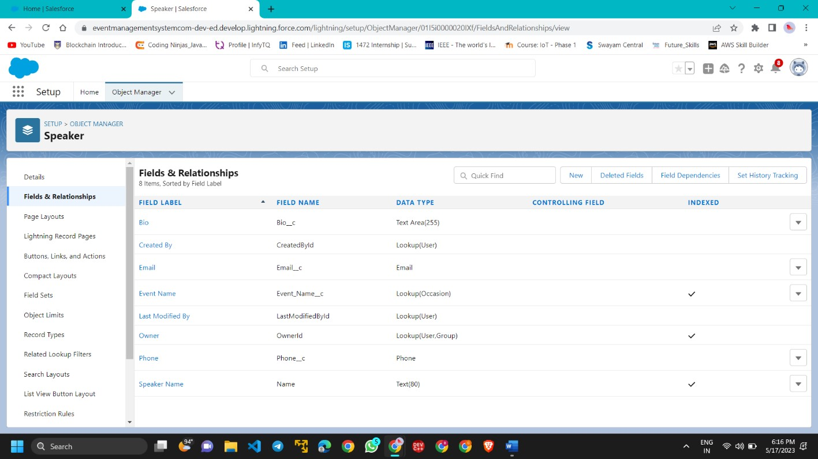

* + - Creation Of Fields For The Vendors Objects

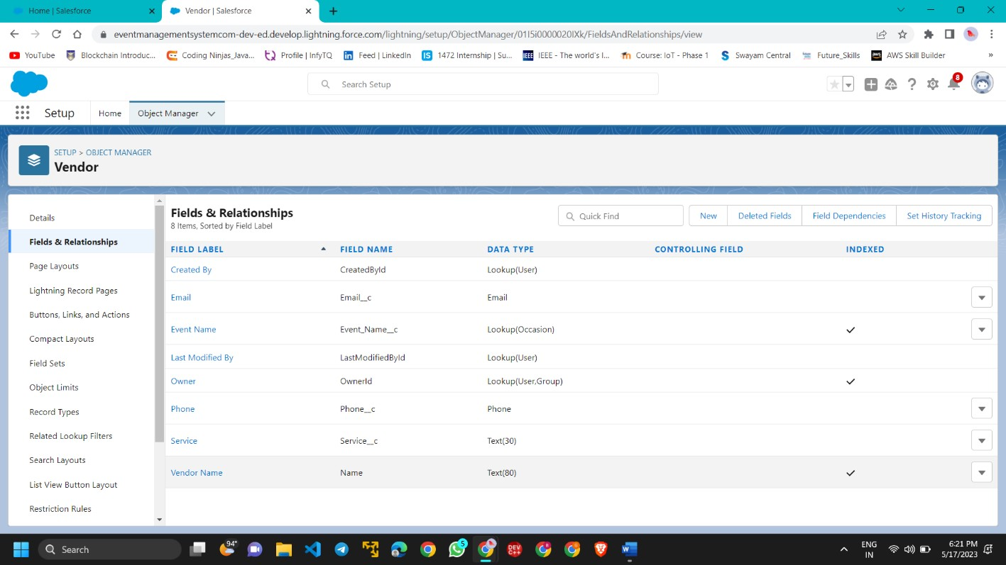

* + - Creation Relationship On Event Service Objects

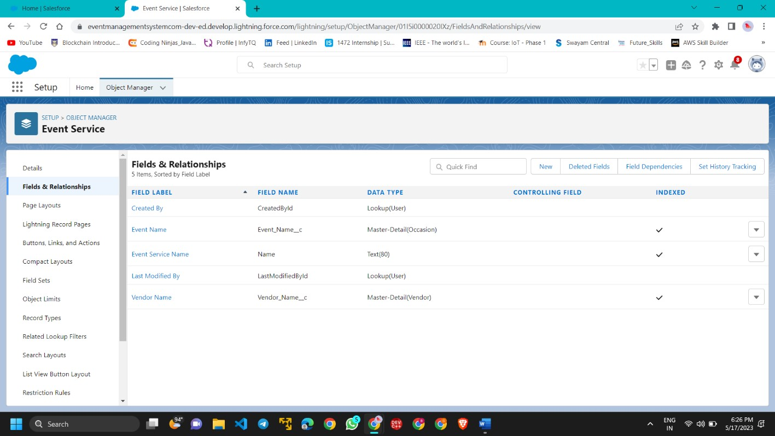

* Profile

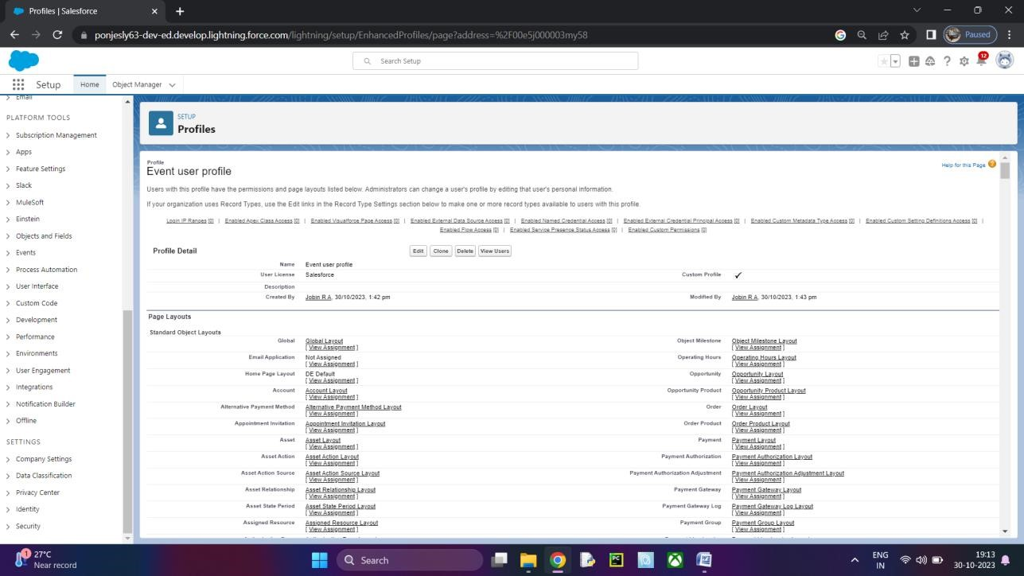

* + - Creation On Profile

* + - Create A Profile with The Profile Name As “Event Vendors Profile”

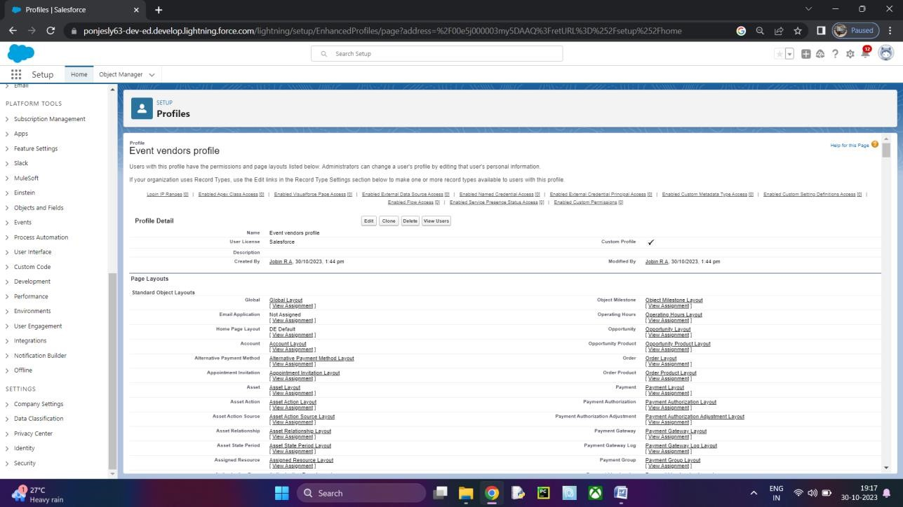

* User
  + - Creating A User

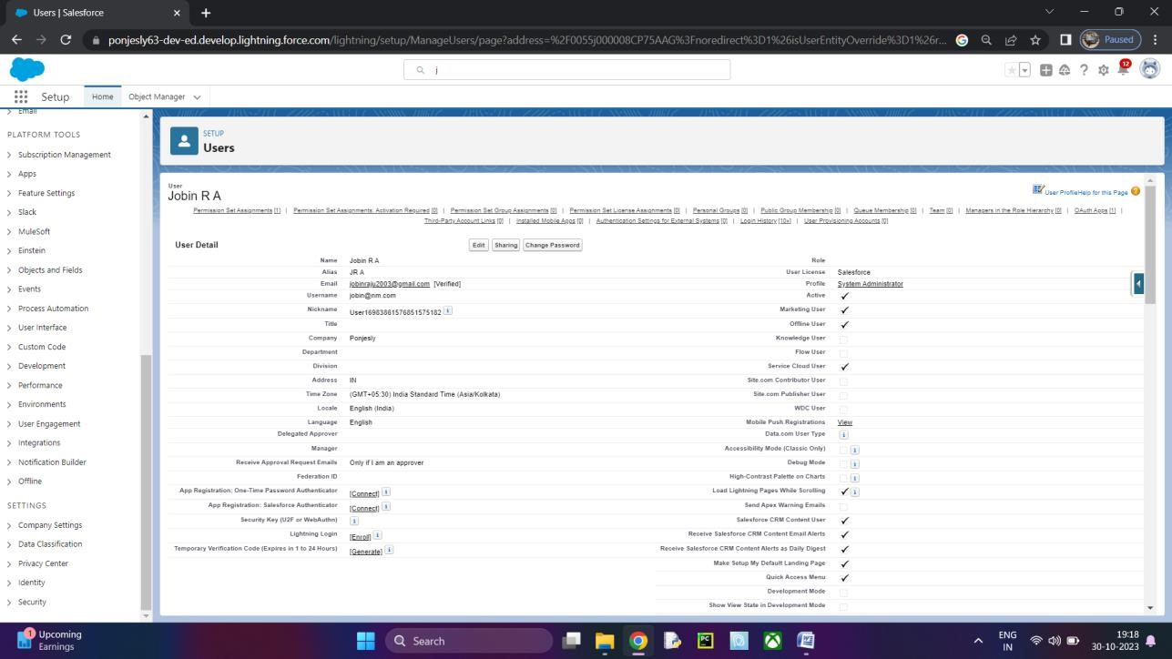

* + - Creating A Another User

* Permission Sets
  + - Creating A Permission Set

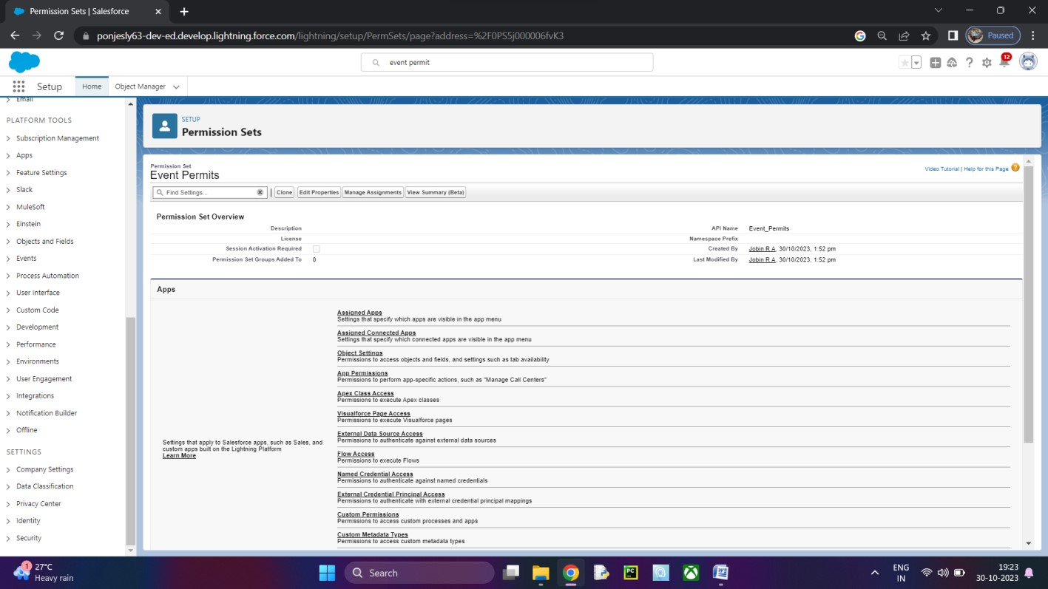

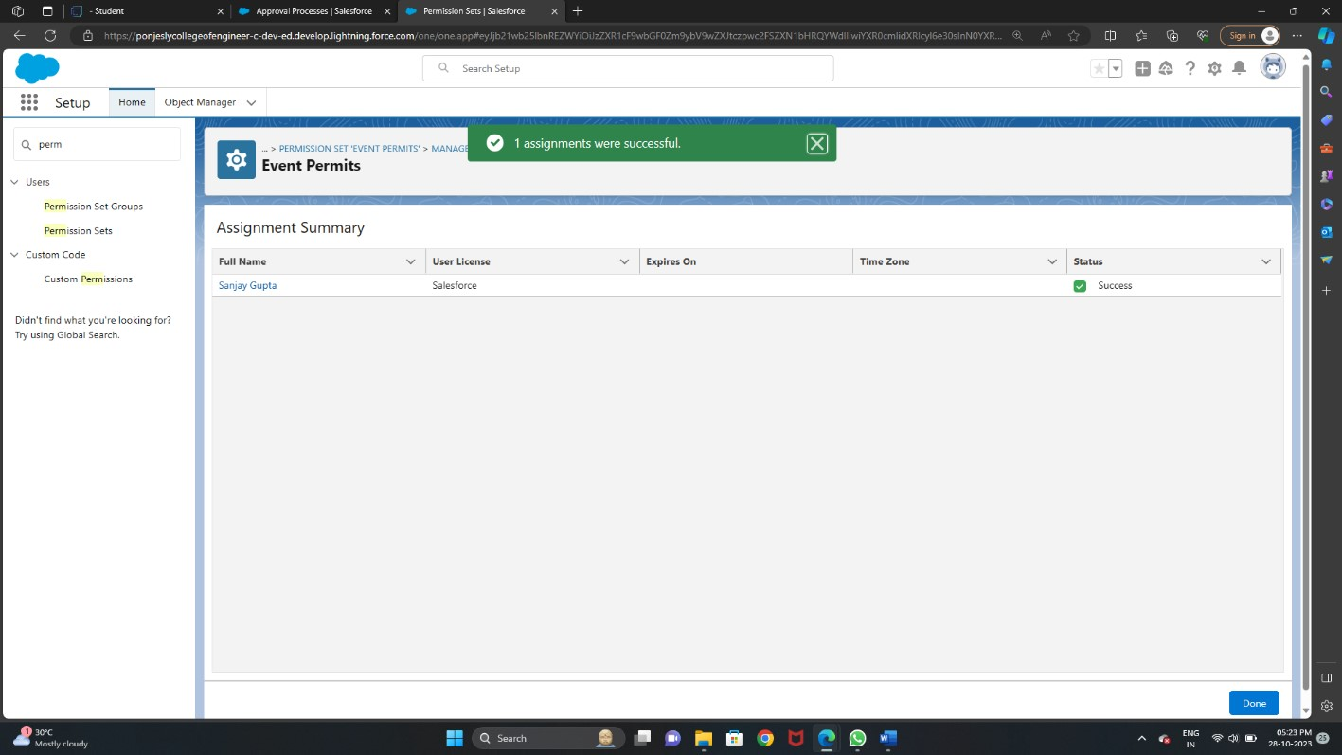

* + - Creating A Another Permission Set

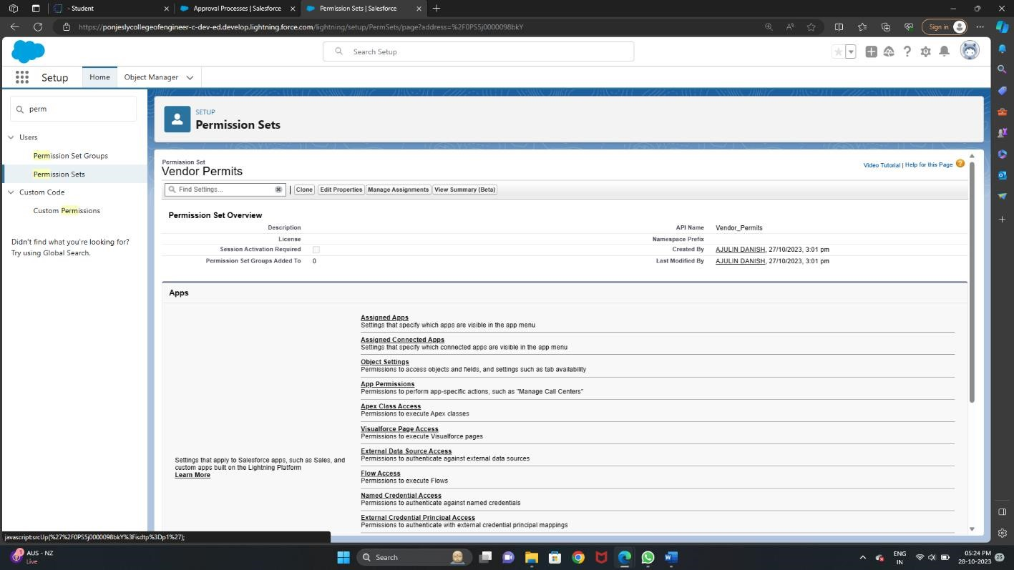

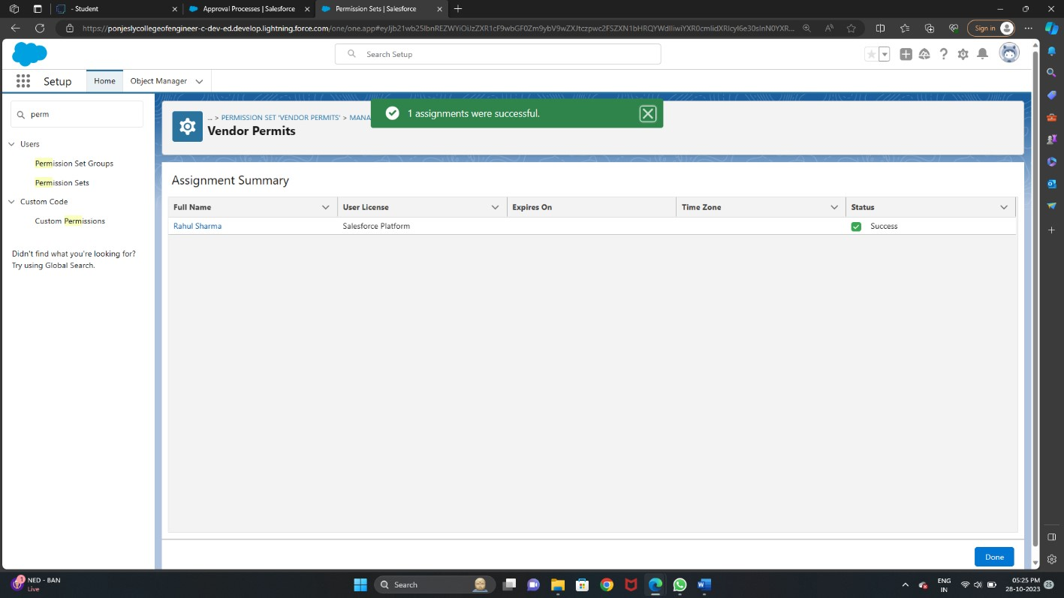

* User Adoption
  + - Create A Record (Occasion)

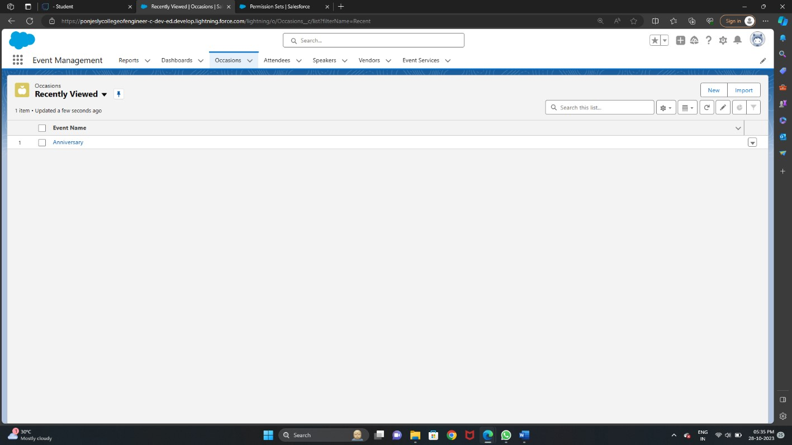

* + - View A Record(Occasion)

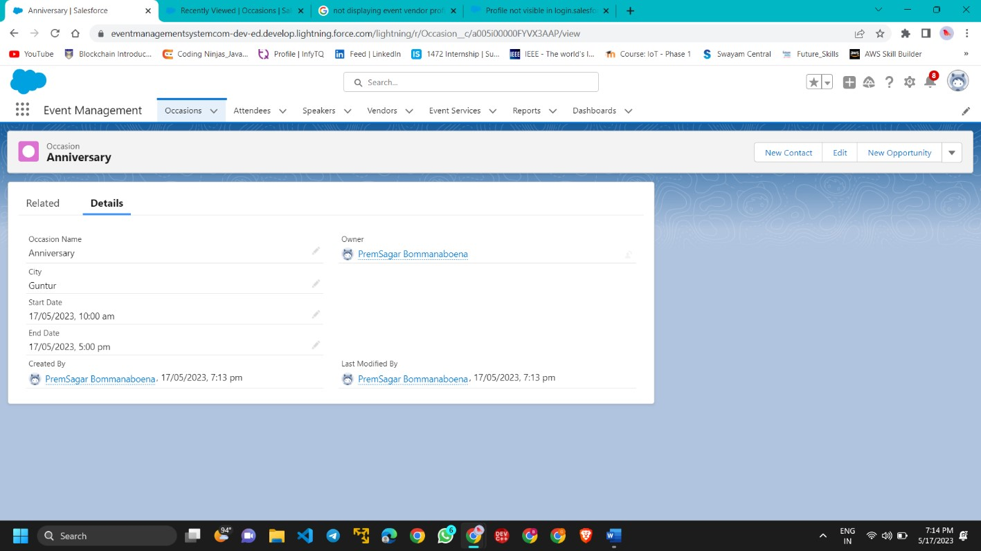

* + - Delete A Record(Occasion)

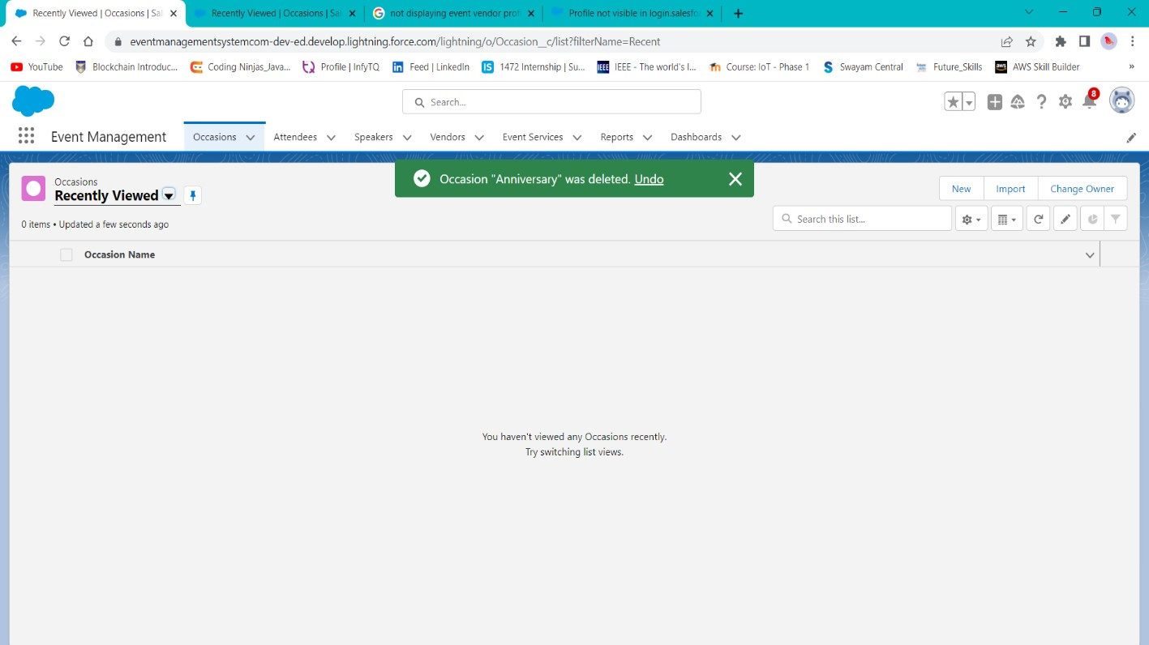

* Reports

▪Creating A Report

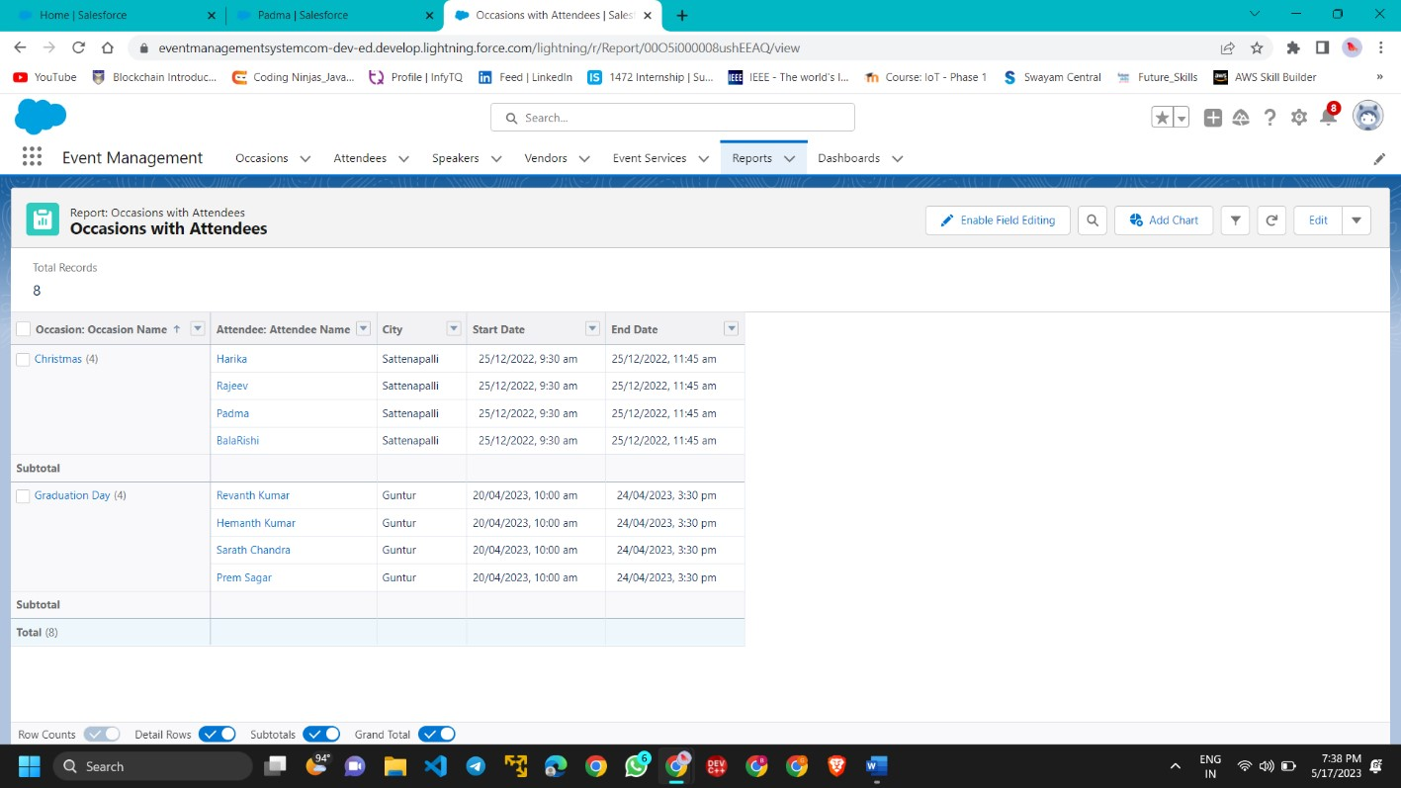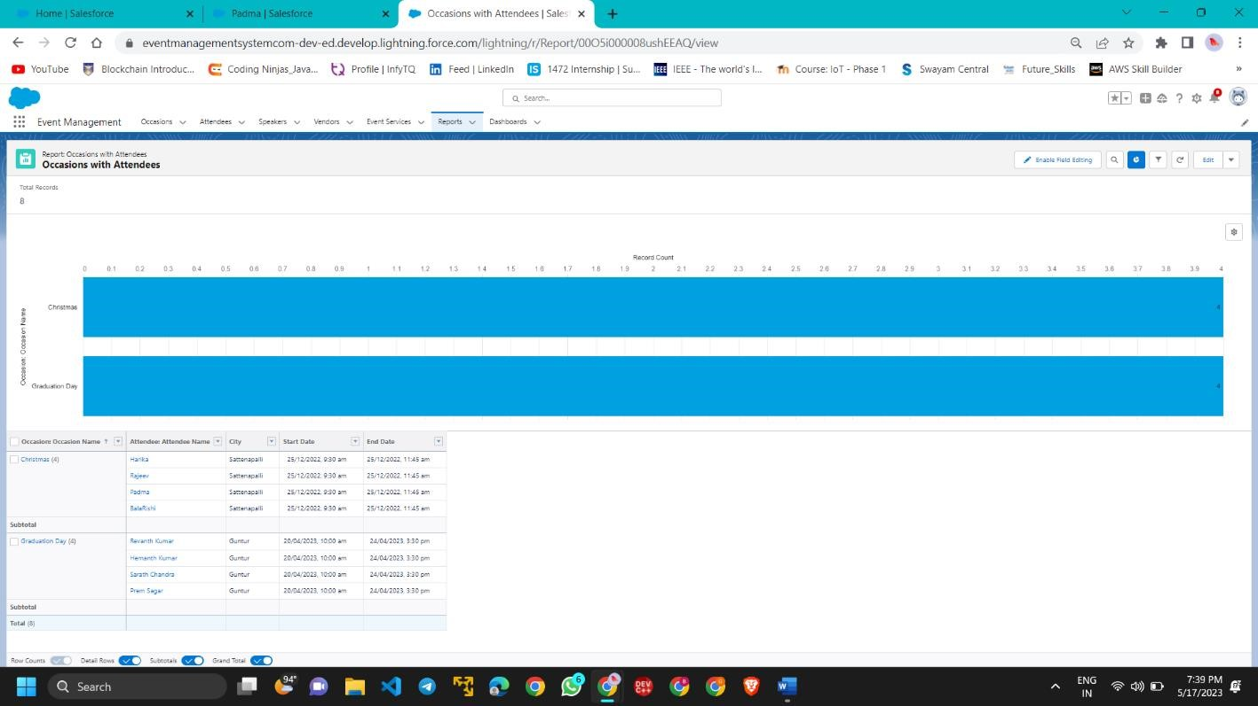

* Dashboard

▪Create A Dashboard

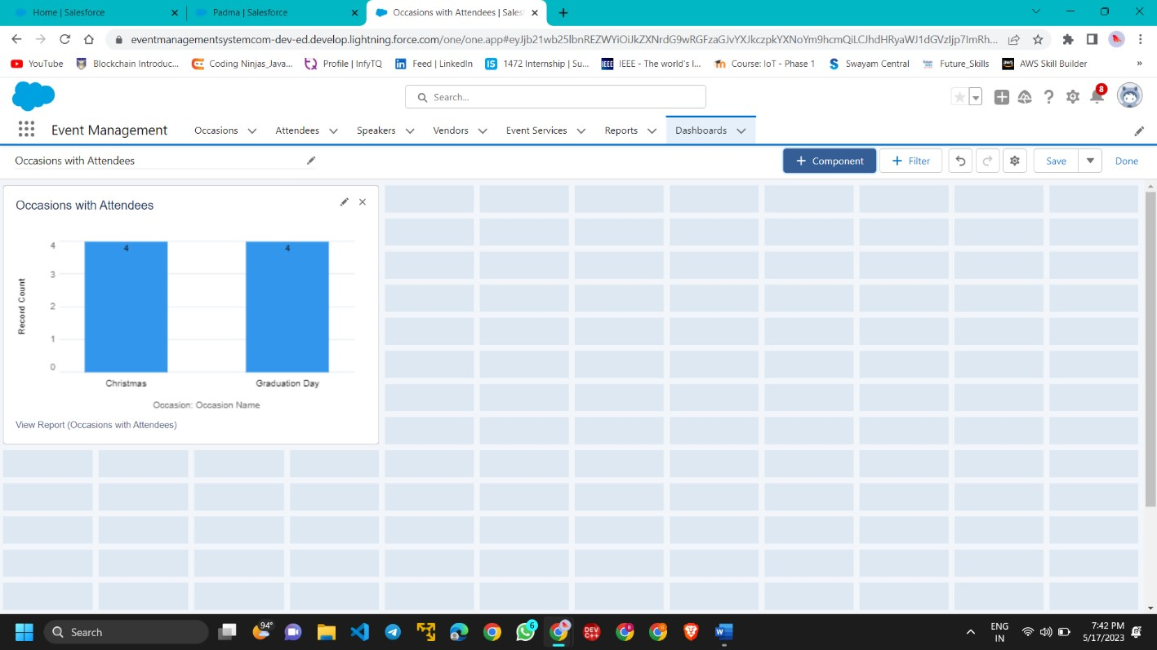

* View Reports And Dashboards

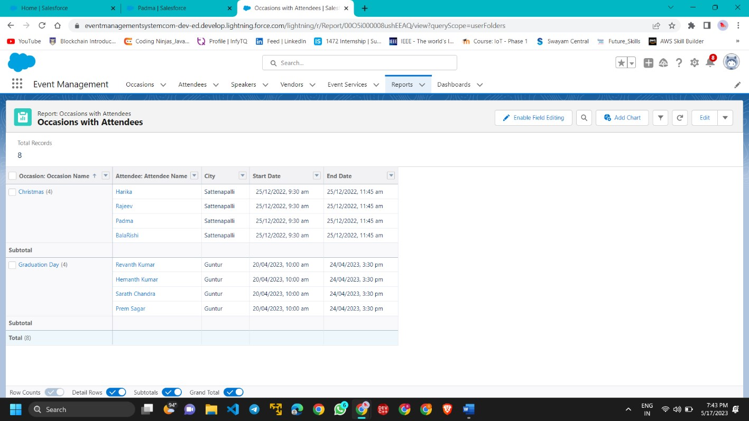

* + - View Report

* + - View Dashboard

